Press Release – Press Release – Press Release – Press Release

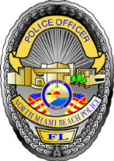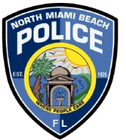
City of North Miami Beach Police Department
Media Relations Office
16901 NE 19th Avenue
North Miami Beach, FL 33162

FOR IMMEDIATE RELEASE J. Scott Dennis – Chief of Police April 5, 2014

Contacts: Major Kathy Katerman
(305) 949-5500
(305) 525-7014 Cell Phone
E-mail: Kathy.katerman@nmbpd.org

Police shooting

Date / Time: Saturday April 5, 2014 at 1:26 A.M.
Case number: 2014-0405-05
Location: 1400 block of NE 159 St. North Miami Beach, Florida 33162

At 1:26 a.m. in the 1400 block of NE 159 St, North Miami Beach Police officers were parked on the swale working a special undercover detail. When for no apparent reason, an armed subject came out of an adjacent house and approached the officers seated in their car. The armed man was told by police to show his hands, the gunman refused to comply, and at some point shots were fired by our officer. The subject was shot twice and taken to Ryder Trauma Center, where he is said to be in stable condition. The investigation is still ongoing at this time. No further details are available; as this is an open investigation.

