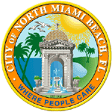
City of North Miami Beach, Florida
OFFICE OF THE CITY CLERK

May 28, 2021

Sent via U.S Mail and email

Candidate Michael Joseph
P.O. Box No. 613635
North Miami Beach, Florida 33261

Subject: Campaign Treasurer’s Reports

Dear Candidate Joseph:

Please be advised that after consultation with the Office of the City Attorney, I am rescinding the previous letters dated May 7, 2021, imposing fines for filing a late Campaign Treasurer’s Report. As a result, no fines are being assessed against you.
Therefore, your Campaign Treasurer’s Reports are deemed timely and no further action is required on your part. If you have any questions, please feel free to contact me.

Sincerely,
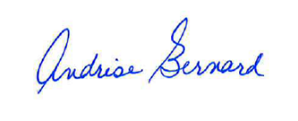
Andrise Bernard, CMC, City Clerk

c: Office of the City Attorney, North Miami Beach

