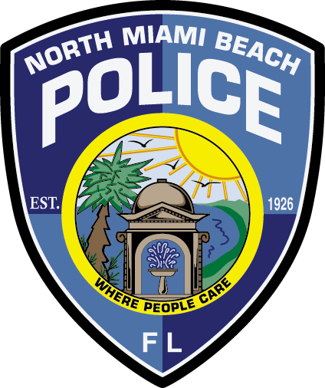
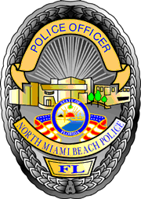
City of North Miami Beach, Florida
Police Department

Memorandum No.

Date: | June 30, 2021
To: | Arthur H. Sorey, III, City Manager
From: | Jason F. Ochoa, Major
Subject: | Proposed Phone for NMBPD Communications Solutions

The purpose of this memorandum is to provide a proposal to resolve the phone issue. Upon researching and contacting AT&T, the North Miami Beach Police Department (NMBPD) has several points within the NMBPD Communication Section regarding the phone system. The primary issue is the aging Primary Rate Interface (PRI) line within the NMBPD and City Hall. A PRI is an end-to-end, digital telecommunications connection that allows for 23 concurrent transmissions of voice, data, or video traffic between the network and the user. The PRI lines are physical pieces of equipment. The recommendation of AT&T is to upgrade to AT&T's Internet Protocol (IP) Flexible Reach Concurrent Calls.

The AT&T IP Flexible Reach is an integrated access, a converged solution designed to deliver outbound, inbound, local, and long-distance calling over AT&T's IP and Virtual Private Network (VPN) services. AT&T IP Flexible Reach can also be referred to as a Session Initiation Protocol (SIP) trunking solution, which is a service offered by a communications service provider that uses the protocol to provision Voice-over IP (VoIP) connectivity between an on-premises phone system and the public switched telephone network (PSTN). To upgrade the NMBPD’s PRI to the AT&T IP Flexible Reach is $11,616. The total cost to upgrade the City Hall and the NMBPD is $60,000. City's Information Technology Department (IT) could only handle this project. AT&T stated 30 days of completion from the date of a signed contract.

The second phase will correct the current Cisco phone system in the Communications Sections and correct the call management/flow that comes into the center. The Cisco phone system was not designed for primary or secondary public safety answering points (PSAP). The NMBPD Communications Section is classified as a secondary PSAP center, which means 911 calls are transferred to NMBPD Communications Sections by the Miami-Dade Police Department. After researching several emergency contact centers, we believe that the Carbyne Apex Call management platform will fit our agency's needs. Carbyne's APEX emergency operations systems provide the tools to meet our residents' expectations.

Centralizing lifesaving tools and live communications channels into one platform provides call takers and dispatchers the simplicity they need to manage complex incidents. The Apex platform will be a long-term solution that can be implemented with other technologies for future growth, including the city's implementation of the Smart City. The estimated cost for the project at the moment is $100,000. On Monday, June 28, 2021, and Tuesday, June 29, 2021, Carbyne's design team conducted a site survey of our communication unit. As a result, this proposal may potentially come at a lower cost. The police department will take the lead on this project within the estimated time frame of thirty days of completion. Throughout the process, the police department will keep timelines and weekly benchmark meetings with our vendors and City IT personnel to ensure no steps are missed or skipped along the way. These meetings will also help mitigate any shortfalls within the time frame, budget, or otherwise.

The final phase will be to conduct a complete analysis of all police department network switches.

JO/

